**Objective:**

**Practice retrieving complex data sets that span across multiple related tables, allowing for better understanding of multi-dimensional data analysis.**

**Joins: Join, Left Outer Join, Right Outer Join, Self-Join**

**Consider the following database tables and write the solution for the given queries.**

**Tables: Employee (eid, ename, salary, doj, comm, did)**

**Department (did, departmentname, location)**

**Sample Data in Employees Table:**

**Q1) Problem Statement: Write a query to retrieve the names of employees along with their corresponding department names.**

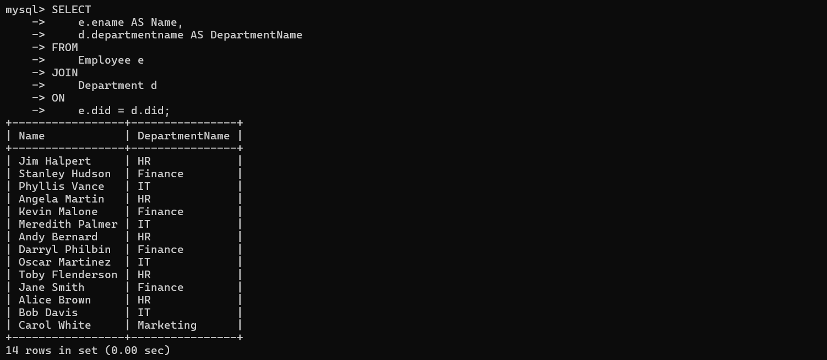

**Q2) Problem Statement: Write a query to find employees who work in departments located in either New York or London and have a salary greater than 60,000. Display their names, department names, locations, and salaries.**

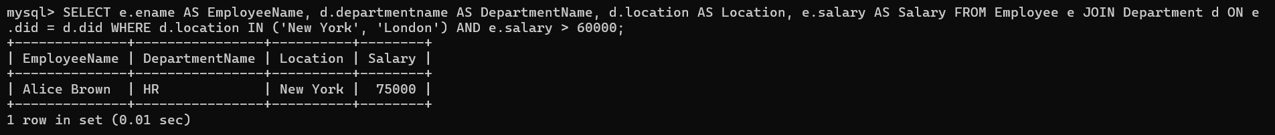

**Q3 )Problem Statement: Write a query to retrieve all employees and their corresponding department names, even if the employee is not assigned to any department.**

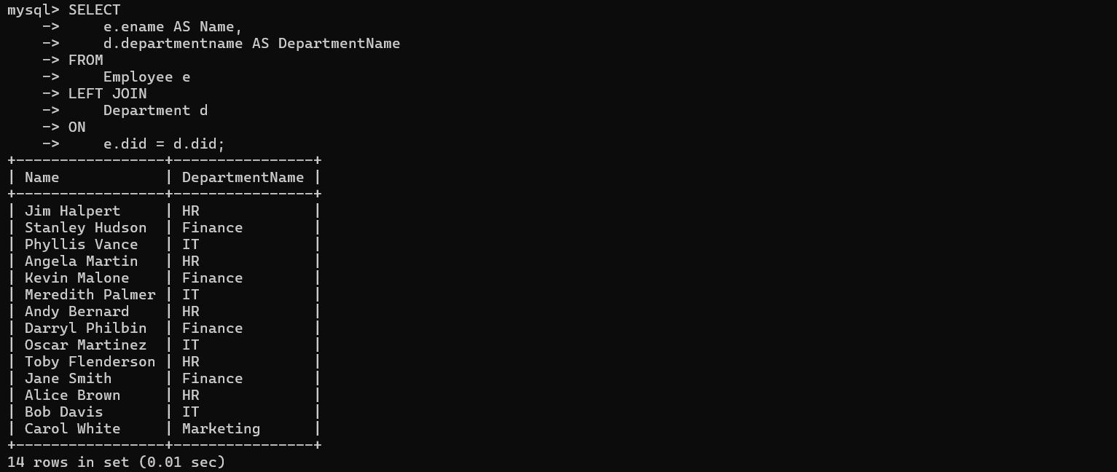

**Q4) Problem Statement: Write a query to retrieve the names of all employees, their department names, and the location of their departments. Also, include employees who are not assigned to any department.**

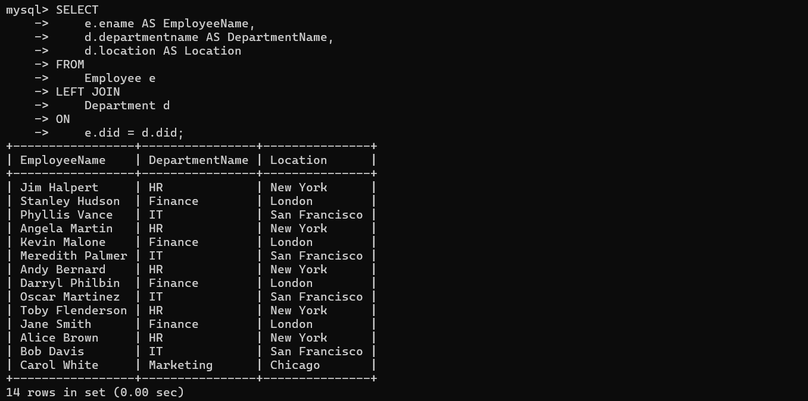

**Q5) Problem Statement: Write a query to retrieve all departments and their corresponding employees, even if a department has no employees assigned to it.**

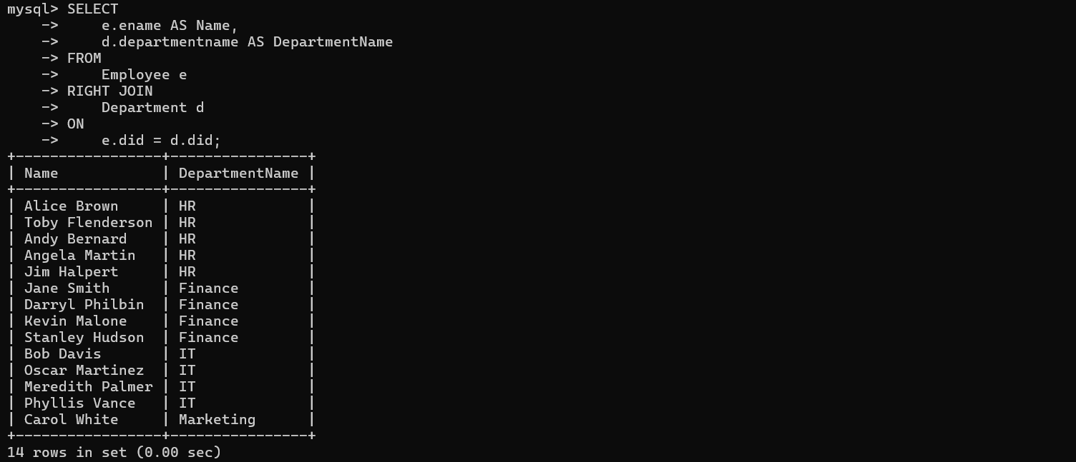

**Q6) Problem Statement: Write a query to retrieve all departments along with the names of employees assigned to them. If no employees are assigned, display "No Employees" in the employee name field. Also, include the department's location.**

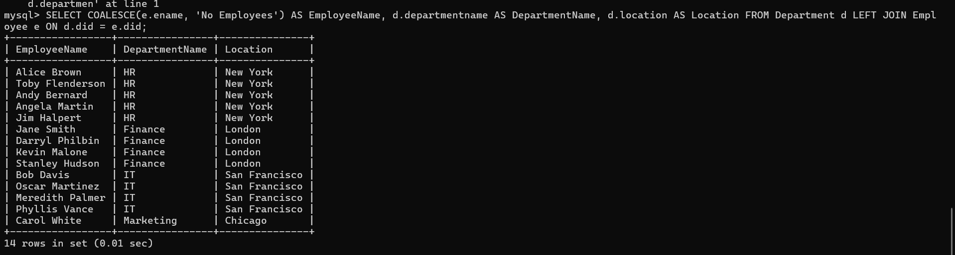

**Q7) Problem Statement: Write a query to find pairs of employees who work in the same department.** 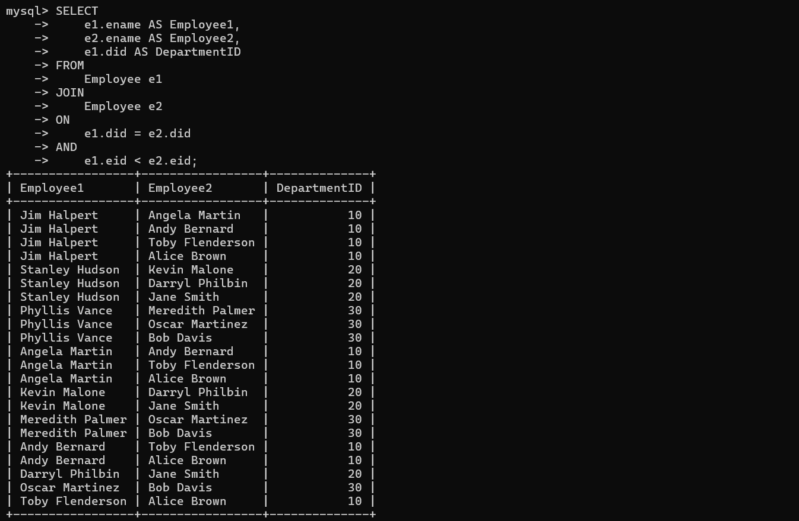

**Q8) Problem Statement: Write a query to display employees names, working DepartmentName and their salary grade**

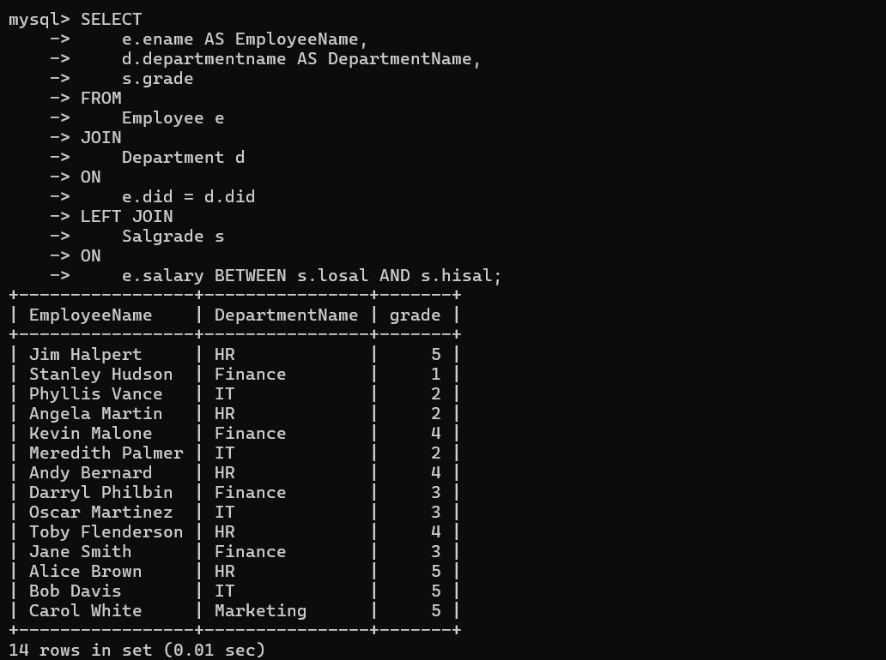

**Q9) Problem Statement: Write a query to calculate the average salary of employees in each department and list the department names and locations along with this average salary. Include only those departments that have more than one employee.** 